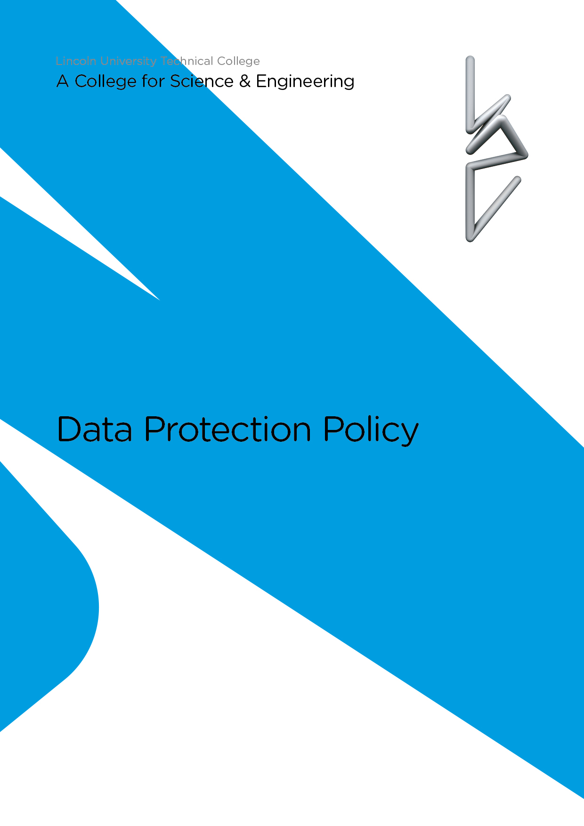

Equality and Diversity Statement

Lincoln UTC strives to treat all its members and visitors fairly and aims to eliminate unjustifiable discrimination on the grounds of gender, race, nationality, ethnic or national origin, political beliefs or practices, disability, marital status, family circumstances, sexual orientation, spent criminal convictions, age or any other inappropriate grounds.

LINCOLN UTC

DATA PROTECTION POLICY

CONTENTS

Para | Content
1 | Purpose
2 | Aims
3 | Introduction
4 | Status of the Policy
5 | Notification of Date Held and Processed
6 | Responsibilities of Staff
7 | Data Security
8 | Student Obligations
9 | Rights to Access Information
10 | Publication of Lincoln UTC Information
11 | Subject Consent
12 | Processing Sensitive Information
13 | The Data Controller and the Designated Data Controller
14 | Examination Marks
15 | Retention of Data
16 | Conclusion
Appendix | - Staff Guidelines for Data Protection
- Staff Checklist for Recording Data
- Guidelines for Retention of Personal Data
 | - GDPR Teacher Notice

1 PURPOSE

1.1 Lincoln UTC staff, or others, who process or use any personal information must ensure that they follow the principles of Data Protection at all times. In order to ensure that this happens, Lincoln UTC has developed this Data Protection Policy.

2 AIMS

2.1 The aims of the policy include the following:

- To explain how data is held and processed;
- To explain the responsibilities of staff under the Data Protection Act and in line with GDPR regulations;
- To explain the principles of data security;
- To explain student obligations;
- To provide information relevant to the rights of access to information;
- To state how and what information will be published;
- To explain the process of data collection and to ensure subject consent is obtained;
- To provide information on the processing of sensitive information;
- To state the position in respect of student assessment results;
- To provide information on the retention of data.

3 Introduction

3.1 Lincoln UTC needs to keep certain information about its employees, students and other users to allow it to monitor performance, achievements and health and safety. It is also necessary to process information so that staff can be recruited and paid, courses organised and legal obligations to funding bodies and government complied with. To comply with the law, information must be collected and used fairly, stored safely and not disclosed to any other person unlawfully. To do this, Lincoln UTC must comply with the data protection principles which are set out in the Data Protection Act 1998 [the 1998 Act]. In summary these state that personal data shall:

- Be obtained and processed fairly and lawfully;
- Be obtained for a specified and lawful purpose and shall not be processed in any manner incompatible with that purpose;
- Be adequate, relevant and not excessive for those purposes;
- Be accurate and kept up to date;
- Not be kept longer than is necessary for that purpose;
- Be processed in accordance with the data subject’s rights;
Be kept safe from unauthorised access, accidental loss or destruction;
- Not be transferred to a country outside the European Economic Area, unless that country has equivalent levels of protection for personal data.

4 Status of the Policy

4.1 This policy does not form part of the formal contract of employment, but it is a condition of employment that employees will abide by. Any failures to follow the policy can therefore result in disciplinary proceedings, including dismissal.

4.2 Any member of staff who considers that the policy has not been followed in respect of personal data about themselves should raise the matter with the designated data controller. If the matter is not resolved it should be raised as a formal grievance.

5 Notification of Data Held and Processed

5.1 All staff, students and other users are entitled to know:

- What information Lincoln UTC holds and processes about them and why;
- How to gain access to it;
- How to keep it up to date;
- What Lincoln UTC is doing to comply with its obligations under the 1998 Act.

5.2 Lincoln UTC will provide all new staff with a standard form of notification. This will state all the types of data Lincoln UTC holds and processes about them, and the reasons for which it is processed.

6 Responsibilities of Staff

6.1 All staff are responsible for:

- Checking that any information that they provide to Lincoln UTC in connection with their employment is accurate and up to date;
- Informing, and providing supporting evidence to Lincoln UTC of any changes to information, which they have provided. e.g. changes of name/address;
- Informing Lincoln UTC of any errors or changes. Lincoln UTC cannot be held responsible for any errors unless the staff member has informed Lincoln UTC of them;
- Ensuring that data is not openly available and is secure at all times:
A copy of the GDPR Expectations / Teacher Notice for all staff at Lincoln UTC can be found at the end of this document

6.2 If and when, as part of their responsibilities, staff collect information about other people, (i.e. about students course work, opinions about ability, references to other academic institutions, or details of personal circumstances), they must comply with the guidelines for staff, which are set out in appendix 1.

7 Data Security

7.1 All staff are responsible for ensuring that:

- Any personal data which they hold is kept securely;
- Personal information is not disclosed either orally or in writing, or accidentally or otherwise, to any unauthorised third party.

7.2 Staff should note that unauthorised disclosure will usually be a disciplinary matter and may, in some cases, be considered gross misconduct.

7.3 Personal information should be:

- Kept in a locked filing cabinet / in a locked drawer;
- Password protected if it is kept electronically.

8 Student Obligations

8.1 Students must ensure that all personal data provided to Lincoln UTC is accurate and up to date. They must ensure that changes of address, etc, are notified to the Data Manager person as appropriate.

8.2 Students who use Lincoln UTC computer facilities may, from time to time, process personal data. If they do, they must notify the data controller. Any student who requires further clarification about this should contact the IT Manager.

9 Rights to Access Information

9.1 Staff, students and other users of Lincoln UTC have the right to access any personal data that is being kept about them either on computer or in personnel files. Any person who wishes to exercise this right should contact the designated data controller.

9.2 In order to gain access, an individual may wish to receive notification of the information currently being held. This request should be made in writing to the designated data controller.

9.3 Lincoln UTC aims to comply with requests for access to personal information as quickly as possible, but will ensure that it is provided within 40 days unless there is good reason for delay. In such cases, the reason for delay will be explained in writing to the data subject making the request.

10 Publication of LincolN UTC Information

10.1 Information that is already in the public domain is exempt from the 1998 Act. It is Lincoln UTC policy to make as much information public as possible, and in particular the following information will be available to the public for inspection:

- Name and contacts of Lincoln UTC Governors;
- List of staff;
- Photographs of key staff.

10.2 The Lincoln UTC internal phone list will not be a public document.

10.3 Any individual who has good reason for wishing details in these lists or categories to remain confidential should contact the Principal.

11 Subject Consent

11.1 In many cases, Lincoln UTC can only process personal data with the consent of the individual. In some cases, if the data is sensitive, express consent must be obtained. Agreement to Lincoln UTC processing some specified classes of personal data is a condition of acceptance of a student onto any course, and a condition of employment for staff. This may include information about previous criminal convictions.

11.2 Some jobs or courses will bring the applicants into contact with children, including young people between the ages of 16 and 18. Lincoln UTC has a legal duty to ensure that staff are suitable for the job, and students suitable for the courses offered. Lincoln UTC also has a duty of care to all staff and students and must therefore make sure that employees and those who use Lincoln UTC facilities do not pose a threat or danger to other users.

11.3 Lincoln UTC may also ask for information about particular health needs, such as allergies to particular forms of medication, or any conditions such as asthma or diabetes. Lincoln UTC will only use the information in the protection of the health and safety of the individual but will need consent to process in the event of a medical emergency.

11.4 All prospective staff and students will be asked to provide personal details when an offer of employment or a course place is made. A refusal to provide such personal details form can result in the offer being withdrawn.

12 Processing Sensitive Information

12.1 Sometimes it is necessary to process information about a person’s health/disability, criminal convictions, race, gender, religion, sexual orientation, transgender and family details.

12.2 This may be to ensure Lincoln UTC is a safe place for everyone, or to operate other Lincoln UTC policies, such as the sick pay policy or equal opportunities policy. Offers of employment or course places may be withdrawn if an individual refuses provide personal details without good reason. More information about this is available from the designated data controller.

13 The Data Controller and the Designated Data Controller

13.1 Lincoln UTC as a corporate body is the ‘data controller’ and the Board is therefore ultimately responsible for implementation. However, the designated data controllers will deal with day-to-day matters.

13.2 Lincoln UTC has two designated data controllers. They are the Principal and the Vice Principal in respect of student issues and employment issues.

14 Examination Marks

14.1 Students will be entitled to information about their marks for both coursework and examinations. However, this may take longer than other information to provide. Lincoln UTC may withhold certificates, accreditation or references in the event that all books and equipment have not been returned to Lincoln UTC.

15 Retention of Data

15.1 Lincoln UTC will keep some forms of information for longer than others. Information about students cannot be kept indefinitely, unless there are specific requests to do so. In general information about students will be kept for a maximum of five years after they leave Lincoln UTC. This will include:

- Name and address;
- Academic achievements, including marks for coursework;
- Copies of any reference written.

15.2 All other information, including any information about health, race or disciplinary matters will be destroyed within three years of the course ending and the student leaving Lincoln UTC.

15.3 If students leave the UTC at 16 to study at another school or college, their personal files and online CTF files will be sent via secure access to their new school or college.

15.4 Lincoln UTC will need to keep information about staff for longer periods of time. In general, all information will be kept for six years after a member of staff leaves Lincoln UTC. Some information will be kept for much longer. This will include information necessary in respect of pensions, taxation, potential or current disputes or litigation regarding the employment, and information required for job references. A full list of information with retention times is available from the data controller.

16 Conclusion

16.1 Compliance with the 1998 Act is the responsibility of all members of Lincoln UTC. Any deliberate breach of the Data Protection Policy may lead to disciplinary action being taken, or access to Lincoln UTC facilities being withdrawn, or even a criminal prosecution. Any question or concerns about the interpretation or operation of this policy should be taken up with the designated data controller.

APPENDIX 1

Staff Guidelines for Data Protection

1 All staff will process data about students on a regular basis, when marking registers, writing reports or references, or as part of a pastoral or academic supervisory role. The information that staff deal with on a day to day basis will be ‘standard’ and will cover categories such as:

● General personal details such as name and address;

● Details about class attendance, course work marks and grades and associated comments;

● Notes of personal supervision, including matters about behaviour and discipline.

2 Information about student’s physical or mental health; sexual life; political or religious views; trade union membership or ethnicity or race is sensitive and can only be collected and processed with student consent. For example, recording information about dietary needs, for religious or health reasons prior to taking students on a field trip; recording information that a student is pregnant, as part of pastoral duties. All student personal information is recorded in SIMS. However, if the nature of the details held by Lincoln UTC are sensitive, this shall be recorded on CPOMS.

3 All staff have a duty to make sure that they comply with the data protection principles, which are set out in this policy. In particular, staff must ensure that records are:

● Accurate;
● Up-to-date;
● Kept and disposed of safely.

4 Lincoln UTC will designate staff in each area as ‘authorised staff’. These staff are the only staff authorised to hold or process data that is:

● Not standard data;
● Sensitive data.

The only exception to this will be if a non-authorised staff member is satisfied that the processing of the data is necessary:

● In the best interests of the student or staff member, or a third person, or Lincoln UTC;
● He / she has either informed the authorised person of this or has been unable to do so and processing is urgent and necessary in all the circumstances.

This should only happen in very limited circumstances. For example, a student is injured and unconscious, but in need of medical attention.

5 Authorised staff will be responsible for ensuring that all data is kept securely.

6 Staff must not disclose personal data to any student, unless for normal academic or pastoral purposes, without authorisation or agreement from the data controller, or in line with Lincoln UTC policy.

7 Staff shall not disclose personal data to any other staff member except with the authorisation or agreement of the designated data controller, or in line with Lincoln UTC policy.

8 Before processing any personal data, all staff should consider the checklist.

Staff Checklist for Recording Data

● Do you really need to record the information?

● Is the information ‘standard’ or is it ‘sensitive’?

● If it is sensitive, do you have the data subject’s express consent?

● Has the student been told that this type of data will be processed?

● Are you authorised to collect/store/process the data?

● If yes, have you checked with the data subject that the data is accurate?

● Are you sure that the data is secure?

● If you do not have the data subject’s consent to process, are you satisfied that it is in the best interests of the student or the staff member to collect and retain the data?

● Have you reported the fact of data collection to the authorised Data Controller?
Guidelines for Retention of Personal Data

Type of Data | Suggested Retention Period | Reason
Personnel files including training records and notes of disciplinary and grievance hearings. | 6 years from the end of employment | References and potential litigation
Application forms/interview notes | At least 6 months from the date of the interviews. | Time limits on litigation
Facts relating to redundancies where less than 20 redundancies | 3 years from the date of redundancy | As above
Facts relating to redundancies where 20 or more redundancies | 12 years from date of redundancies | Limitation Act 1980
Income Tax and NI returns, including correspondence with tax office | At least 3 years after the end of the financial year to which the records relate | Income Tax (Employment) Regulations 1993
Statutory Maternity Pay records and calculations | As Above | Statutory Maternity Pay (General) Regulations 1986
Statutory Sick Pay records and calculations | As Above | Statutory Sick Pay (General) Regulations 1982
Wages and salary records | 6 years | Taxes Management Act 1970
Accident books, and records and reports of accidents | 3 years after the date of the last entry | RIDDOR 1985
Health records | During employment | Management of Health and Safety at Work Regulations
Health records where reason for termination of employment is connected with health, including stress related illness. | 3 years | Limitation period for personal injury claims
Medical Records kept by reason of the Control of Substances Hazardous to Health Regulations 1994 | 40 years | COSHHR 1994
Student records, including academic achievements, and conduct | At least 6 years from the date the student leaves Lincoln UTC, in case of litigation for negligence.  At least 10 years for personal and academic references. | Limitation period for negligence


APPENDIX 2

GDPR Teacher Notice

Lincoln UTC proposes the following guidance for its staff in order to comply with GDPR:

- Staff will follow a ‘clear desk’ policy in classrooms and offices when leaving the room for the end of the day or prolonged periods of time.

- Staff will ensure that any USB drives containing personal data are encrypted and password protected:
  - Guidance on doing this can be gained by contacting the IT Manager.

- Staff will ensure any personal devices used to access data or work emails will be password protected. This includes mobile phones, tablets, and laptops:
  - Guidance on doing this can be gained by contacting the IT Manager.

- Staff will ensure their computers, linked to the UTC directly or via the use of a remote desktop, either in the UTC or at home, are locked when leaving them unattended.

- Emails about students that are sent internally should ONLY contain the student’s initials in the subject bar.

- Where possible emails that are sent externally containing data on students should be anonymised should be encrypted.
  - Guidance on doing this can be gained by contacting the IT Manager.

- Any documents containing data that are printed should be stored securely and shredded when no longer required.

Staff are expected to sign and return a GDPR document
available from the Vice Principal to confirm that you understand
and will comply with the above ‘Best Practice’ expectations.

